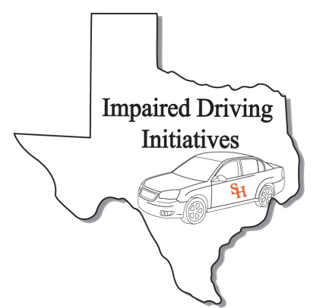
DRE Recertification Registration Form
(Please print clearly. This information will be used for your certificate and official records)

Personal Information
Name:
Last First MI
TCOLE PID:
IACP DRE Number:
Date of Birth:
Home Address*
Street or Box No

City State Zip
Work Phone:
Fax Number:
Cellular Phone
Email Address:
Peace officer Status: Full Time: Reserve: Cadet: Other:
(if you are a peace officer, check the appropriate box. This is for your TCOLE records)
Agency/ Company Information
Agency/Company Name:

Agency Address:
Street or Box No

City State Zip
Job Title:

Course Information
Course Title DRE Recertification Credit Hours: 8
Starting Date: March 8, 2018
Ending Date: March 8, 2018
Course Location: San Antonio Police Training Academy
12200SE Loop 410
Site Address
San Antonio TX 78221
City State Zip

DRE Recertification

San Antonio, Texas
March 8, 2018

For Official Use Only
Received By:
Date:
Expiration Date:

After completing application, please e-mail to DRE@SHSU.edu or Fax to 936-294-3263

Signature: Date: Sign:

****NO WALK –INS****

