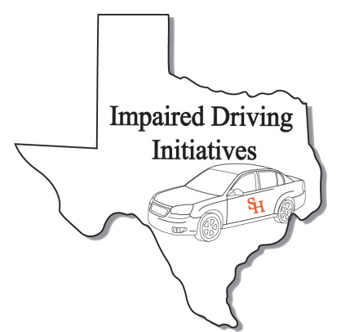
ARIDE Registration Form
(Please print clearly. This information will be used for your certificate and official records)

Personal Information
Name:
Last First MI
TCOLE PID:
Date of Birth:
Home Address*
Street or Box No

City State Zip
Work Phone:
Fax Number:
Cellular Phone
Email Address:
Peace officer Status: Full Time: Reserve: Cadet: Other:
(if you are a peace officer, check the appropriate box. This is for your TCOLE records)
** Attach copy of TCOLE report showing 24 hr SFST course. Registration is not complete until we have report. Exceptions are Texas DPS and TX Park & Wildlife.**

Agency/ Company Information
Agency/Company Name:
Agency Address:
Street or Box No

City State Zip
Job Title:
Course Information
Course Title ARIDE Credit Hours: 16
Starting Date: 02/27/2018
Ending Date: 02/28/2018
Course Location: Plano Police Training (Academy)
4912 14th Street__ ___
Site Address
Plano TX 75074
City State Zip

Advanced Roadside
Impaired Driving
Enforcement

Plano, Texas
February 27-28, 2018

For Official Use Only
Received By:
Date:

After completing application, please e-mail to DRE@SHSU.edu or Fax to 936-294-3263

WALK-INS WILL NOT BE ACCEPTED

Signature: Date: Sign:

