DRE Recertification Registration Form
(Please print clearly. This information will be used for your certificate and official records)

Personal Information
Name:
Last First MI
TCOLE PID:
IACP DRE Number: Date of Birth:
Home Address*
Street or Box No

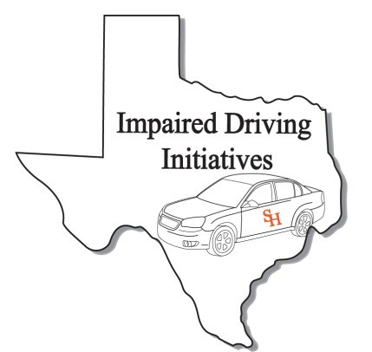DRE Recertification Grand Prairie, Texas
April 4, 2017

City State Zip Work Phone: Fax Number: Cellular Phone Email Address: Peace officer Status: Full Time: Reserve: Cadet: Other: (if you are a peace officer, check the appropriate box. This is for your TCOLE records)

Agency/ Company Information
Agency/Company Name:

Agency Address:
Street or Box No

City State Zip
Job Title:

Course Information
Course Title DRE Recert Credit Hours: 8 Starting Date: April 4, 2017
For Official Use Only Received By: Date: Expiration Date:
Ending Date: April 4, 2017
Course Location: Charles V England Training 310 College
Site Address
Grand Prairie TX 75050
City State Zip

After completing application, please e-mail to DRE@SHSU.edu or Fax to 936-294-3263

Signature: Date: Sign:

