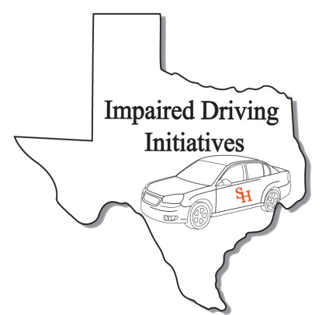
ARIDE Registration Form
(Please print clearly. This information will be used for your certificate and official records)

Personal Information
Name:
Last First MI
TCOLE PID:
Date of Birth:
Home Address*
Street or Box No

City State Zip
Work Phone:
Fax Number:
Cellular Phone
Email Address:
Peace officer Status: Full Time: Reserve: Cadet: Other:
(if you are a peace officer, check the appropriate box. This is for your TCOLE records)
** Attach copy of TCOLE report showing 24 hr SFST course.**
Agency/ Company Information
Agency/Company Name:

Agency Address:
Street or Box No

City State Zip
Job Title:

Course Information
Course Title ARIDE Credit Hours: 16
Starting Date: 12/02/2015
Ending Date: 12/03/2015
Course Location: 1763 US Hwy 281
Site Address
Brownsville TX 78520
City State Zip

Advanced Roadside
Impaired Driving
Enforcement

Brownsville, Texas
December 2-3, 2015

For Official Use Only
Received By:
Date:

After completing application, please e-mail to DRE@SHSU.edu or Fax to 936-294-3263

Signature: Date: Sign:

