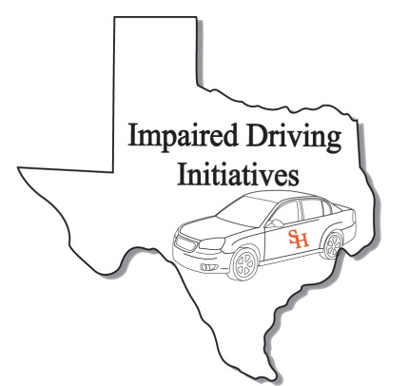
DRE Recertification Registration Form
(Please print clearly. This information will be used for your certificate and official records)

Personal Information
Name:
Last First MI
TCLEOSE PID:
IACP DRE Number:
Date of Birth:
Home Address*
Street or Box No

City State Zip
Work Phone:
Fax Number:
Cellular Phone
Email Address:
Peace officer Status: Full Time: Reserve: Cadet: Other:
(if you are a peace officer, check the appropriate box. This is for your TCOLE records)
Agency/ Company Information
Agency/Company Name:

Agency Address:
Street or Box No

City State Zip
Job Title:

Course Information
Course Title DRE Recert Credit Hours: 8
Starting Date: June 24, 2014
Ending Date: June 24, 2014
Course Location: Harris Co. Sheriff’s Training Academy 2316 Atascocita Rd.
Site Address
Humble TX 77396
City State Zip

DRE Recertification

Humble
June 24, 2014

For Official Use Only
Received By:
Date:
Expiration Date:

After completing application, please e-mail to DRE@SHSU.edu or Fax to 936-294-3263

Signature: Date: Sign:

