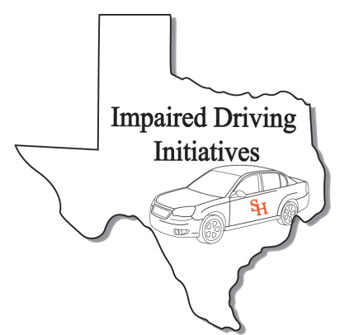
ARIDE Registration Form
(Please print clearly. This information will be used for your certificate and official records)

Personal Information
Name:
Last First MI
TCOLE PID:
Date of Birth:
Home Address*
Street or Box No

City State Zip
Work Phone:
Fax Number:
Cellular Phone
Email Address:
Peace officer Status: Full Time: Reserve: Cadet: Other:
(if you are a peace officer, check the appropriate box. This is for your TCOLE records)
** Attach copy of TCOLE report showing 24 hr SFST course.**
Agency/ Company Information
Agency/Company Name:

Agency Address:
Street or Box No

City State Zip
Job Title:

Course Information
Course Title ARIDE Credit Hours: 16
Starting Date: 04/15/2014
Ending Date: 04/16/2014
Course Location: Concho Valley Regional LEA 2801 W Loop 306, suite A
San Angelo TX 76904
City State Zip

Advanced Roadside
Impaired Driving
Enforcement

San Angelo, Texas
April 15-16, 2014

For Official Use Only
Received By:
Date:

After completing application, please e-mail to DRE@SHSU.edu or Fax to 936-294-3263

Signature: Date: Sign:

