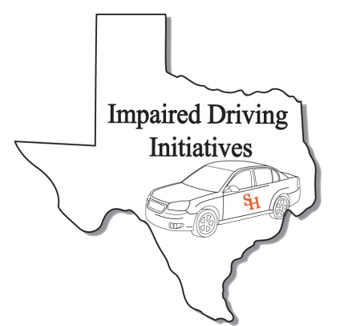
DRE Recertification Registration Form
(Please print clearly. This information will be used for your certificate and official records)

Personal Information
Name:
Last First MI
TCLEOSE PID:
IACP DRE Number:
Date of Birth:
Home Address*
Street or Box No

City State Zip
Work Phone:
Fax Number:
Cellular Phone
Email Address:
Peace officer Status: Full Time: Reserve: Cadet: Other:
(if you are a peace officer, check the appropriate box. This is for your TCOLE records)
Agency/ Company Information
Agency/Company Name:

Agency Address:
Street or Box No

City State Zip
Job Title:

Course Information
Course Title DRE Recert Credit Hours: 8
Starting Date: February 25, 2014
Ending Date: February 25, 2014
Course Location: City of GP Public Safety Training
310 College Street
Site Address
Grand Prairie TX 75050
City State Zip

DRE Recertification

Grand Prairie
February 25, 2014

For Official Use Only
Received By:
Date:
Expiration Date:

After completing application, please e-mail to DRE@SHSU.edu or Fax to 936-294-3263

Signature: Date: Sign:

